New Project or Request Title | EABT Balance Transfer Abandon Email Survey
Requestor | Haleigh Stern
Discover POC(s)  (+ email address, phone) | haleighstern@discover.com; 630-688-4943
Discover Billable Owner | Sheila Hughes
Discover Business Unit (LOB) | Card
Date Submitted | 12/9/2022

Revision History

Date | Version | Author | Description
 | 1 | Haleigh Stern | Initial BRD
12/19/2022 | 2 | Haleigh Stern | Updates post Oracle/BT/Email touch base, all changes marked up
1/6/2023 | 3 | Haleigh Stern | Edited file delivery schedule; cleaned up file section; updated creative section confirming concept 1 usage
2/13/23 | 4 | Haleigh Stern | Added survey data confirmations
2/24/23 | 5 | Haleigh Stern | Update per latest conversation with Oracle (green highlights for BT)
3/2/23 | 6 | Haleigh Stern | Added creative/functionality notes in Creative Requirements section
4/14/23 | 7 | Haleigh Stern | Updated Technical Requirements for EABT Survey file; updated screen shots and interaction notes (highlighted throughout)
4/19/23 | 8 | Haleigh Stern | Updated reporting section as the team works through setting up an automated job to pull response file; also updated the New File data requirements to Y/N for question 1 due to the ability to select multiple responses; added link for Learn More in Creative Requirements
Project/Technical Request Details

Request Type  Is this a net new request? Or is this request modifying an existing process? | New survey landing page and file pass process
Description/Overview  What type of project request is this? i.e. form, new data feed, etc. | New landing page containing a survey:  -please see screenshots at the end of this doc  -functionality to either select one response or all responses that apply and write in custom response  -functionality to error if responses have not been added when clicking submit  -2 pages: page 1 survey and page 2 thanks for feedback  -also need to create a new file process for sending survey responses back to DFS monthly and tying response to individual records (note: requesting an additional file delivery 2 weeks post-launch)
Requested Launch Date | As soon as feasible with asset hand off

Business Impact to

Launch Date

Is this go-live tied to any key initiatives that require meeting this launch date?
Business Impact to Discover  What business need is this request addressing? | Survey will be used in EABT Balance Transfer abandon trigger to collect feedback on why the cardmember did not complete a balance transfer. Fulfills a data need not being met today.
Business Rules  What are the business rules/logic governing this request? Include Lifecycle cadence if applicable. | Entry: link to survey will be included only in EABT trigger. The link will not be added to the website or app so all traffic from solely Oracle email.  Suppression/Removal: No suppression. OK to pass all responses (including repeat responses from a single user)  Page Experience Requirements:  >>Select one response or all responses that apply  >>Type in open text box. See interaction notes next to screenshots for functionality requirements (all previously approved by Oracle team)  >>Error served if responses have not been added when clicking submit  Reporting: Response data will need to pass back tied to individual records monthly. Note: requesting an additional file delivery 2 weeks post-launch.  >Oracle to post file to SFTP. Per Discover requirements, the file will be encrypted. Oracle team please confirm this is the location the file will be posted: /home/cli/dfscorpor_scp/download/  >Ebusiness working with Balance Transfer team to develop job to pull the file, decrypt and post for import to Snowflake.  > File will remain on SFTP for 14 days.  >Oracle will maintain a supplemental table (allowing multiple responses) so we can perform a historical pull if ever needed.  > File will only send delta (new responses since last file send)  File set up: see Technical Requirements/Specifications and Data Feed Details, New File from Oracle on page 7  QA/UAT (End to End):  - Test click through of survey link directs user to the survey landing page  - Test response functionalities listed above (single selection, multiple selections, custom write in, error state for missing required response)  - Test file process for Oracle passing responses to DFS and verify activity is tied to correct record  - We need to ensure the overall page is WCAG AA compliant.
Additional Assets  If this request if modifying existing processes, please provide details on which assets are being impacted (i.e. form URL, email trigger, etc.) | N/A
Success Metrics  What are the KPI’s, how will we measure success? | # of responses submitted  Planning to use response data to inform content strategy and persona development

Please note that Oracle does not view the receipt of this document as the official start of the project or technical work. Please allow time post-receipt for efforts related to scoping and requirements discovery, as well as a kickoff call if deemed necessary. The project manager will provide an official timeline and level of effort (LOE) once all preliminary scoping has been completed and work is ready to commence
Technical Requirements/Specifications and Data Feed Details
EABT Audience File

Data Source | Card Ad Hoc Marketing file
File Name | Standard Naming Convention for DCRD2
Server Location | Not sure where PCM typically sends files
Frequency | Daily file for EABT (but don’t want to limit campaign connection)
File Enclosures | Not sure what this refers to
File Delimiters | Pipe
Encryption? | Yes

File Layout

Data Source | Card Ad Hoc Marketing file (EABT audience file)
File Name | Standard Naming Convention for DCRD2
Server Location | Not sure where PCM typically sends files
Frequency | Daily file for EABT (but don’t want to limit campaign connection)
File Enclosures | Not sure what this refers to
File Delimiters | Pipe
Encryption? | Yes
File Layout (DCRD2 for EABT)
Incoming Data Field Name and Data Type | Sample Data Value | Description i.e. data definitions
MKT_PERM | Y (marketing) Null (service)
ORA_KEY | 12324221230004300000
ACCT_KEY | 0012345678
PRTY_ID | 0012345678
FIN_AGRMNT_TYP | CARD
SEL_DT | 3/14/2018
PRVD_EMAIL_ID | tgelb1@aol.com
CELL_UNQ_ID | E31021248000101
CMPGN_SHRTNM | EABT
CELL_DESC_TXT | Recent-Not Enrolled-SL1,Body1
MAP_SOURCE_CODE | EABT_0101M
ACCT_NBR_LAST4 | 0234
FIRST NAME | TREE
LAST NAME | STUBER
MEMBER_SINCE_DATE | dd-MON-YYYY
OPEN_TO_BUY_AMT | 18104
RWRD_INCNTV_CDE | 000001
PURCH_RATE_APR | 3.99
DSCL_OFFR_1_TXT
OFFR_DUR_MTH_NBR_1
BT_PROMO_APR_1
BT_RSPND_BY_DT | dd-MON-YYYY | Passing in EABT
BT_RATE_EXP_DT_1 | dd-MON-YYYY
BT_FIX_FEE_AMT_1
BT_FEE_RATE_1
BT_FEE_MIN_AMT_1
BT_FEE_MAX_AMT_1
STD_PURCH_APR
STD_BT_FEE_RATE
OFFR_STRT_DT | dd-MON-YYYY
RML_DT | dd-MON-YYYY
STD_BAL_FEE_MIN_AMT
DSCL_VAR_RATE
DSCL_BT_FEE_LTR_VAL
DSCL_OFFR_2_TXT
OFFR_DUR_MTH_NBR_2
BT_PROMO_APR_2
BT_RATE_EXP_DT_2 | dd-MON-YYYY
BT_FIX_FEE_AMT_2
BT_FEE_RATE_2
BT_FEE_MIN_AMT_2
BT_FEE_MAX_AMT_2
BIC_FLAG
MISC_AMOUNT_1 | 100.79
MISC_AMOUNT_2 | 100.79
MISC_AMOUNT_3 | 100.79
MISC_AMOUNT_4 | 100.79
MISC_AMOUNT_5 | 100.79
MISC_DATE_1 | dd-MON-YYYY
MISC_DATE_2 | dd-MON-YYYY
MISC_DATE_3 | dd-MON-YYYY
MISC_DATE_4 | dd-MON-YYYY
MISC_DATE_5 | dd-MON-YYYY
MISC_TEXT_1 | N/A
MISC_TEXT_2 | N/A
MISC_TEXT_3 | N/A
MISC_TEXT_4 | N/A
MISC_TEXT_5 | N/A
Technical Requirements/Specifications and Data Feed Details
New File from Oracle

Technical Requirements/Specifications and Data Feed Details
New File From Oracle

Data Source | EABT audience file + survey landing page
File Name | 80372_EABT_Survey_YYYYMMDD
Server Location | SFTP
Frequency | Monthly (extra file 2 weeks post-launch)
File Enclosures | “
File Delimiters | Pipe
Encryption? | Yes
Technical Requirements/Specifications and Data Feed Details
New EABT Survey Response File
Incoming Data Field Name and Data Type | Sample Data Value | Description i.e. data definitions
ACCT_KEY | 0012345678 | Pulled from EABT file
PRTY_ID | 0012345678 | Pulled from EABT file
SEL_DT | 3/14/2018 | Pulled from EABT file – used in case of duplicates
PRVD_EMAIL_ID | tgelb1@aol.com | Pulled from EABT file
CELL_UNQ_ID | E31021248000101 | Pulled from EABT file
SUBMISSION_STAMP | 2018-08-31 04:37:03 | Timestamp for when the response was submitted
Q1_A | Y or N | Since this is check all that apply, individual field for each response option. Y for selection N for no selection.
Q1_B | Y or N | Since this is check all that apply, individual field for each response option. Y for selection N for no selection.
Q1_C | Y or N | Since this is check all that apply, individual field for each response option. Y for selection N for no selection.
Q1_D | Y or N | Since this is check all that apply, individual field for each response option. Y for selection N for no selection.
Q1_E | Y or N | Since this is check all that apply, individual field for each response option. Y for selection N for no selection.
Q1_F | Y or N | Since this is check all that apply, individual field for each response option. Y for selection N for no selection.
Q1_OPEN | Blank or open text box | Open text box, 500 character limit
Q2_PLAN | A | Only one response accepted. Letter value for each response (e.g., response 1=A; response 2=B; etc.)
Q3_OPEN | This text box will be open ended so confirm whether verbatim text can pass as value | Open text box, 500 character limit

Additional callout: For the open text boxes, need to restrict user entry to only numbers and letters so no symbols are passed that can impact import/export processes.

Creative Requirements
 | Standard or Branch | Link Name | Link Category | URL
1 | Standard | Discover_Logo_Header | Portfolio-BalanceTransfer | http://www.discover.com?/
2 | Standard | Privacy_Policy_Footer | Portfolio-BalanceTransfer | https://www.discover.com/privacy-statement
3 | Standard | Security_Measures_Footer | Portfolio-BalanceTransfer | https://www.discover.com/credit-cards/member-benefits
4 | Standard | Terms_Use_Footer | Portfolio-BalanceTransfer | https://www.discover.com/credit-cards/discover-terms-of-use
5 | Branch | Check_My_Offers_CTA_1 | Portfolio-BalanceTransfer | https://discover.app.link/3p?%243p=e_rs&%24original_url=https%3A%2F%2Fwww.discover.com%2Fcredit-cards%2Fbalance-transfer%2F&deeplink=linktobalxfer
6 | Branch | Learn_More_Text | Portfolio-BalanceTransfer | https://discover.app.link/3p?%243p=e_rs&%24original_url=https%3A%2F%2Fportal.discover.com%2Fcustomersvcs%2FuniversalLogin%2Fac_main%3Flink%3D%252Fcardmembersvcs%252Fhelpcenter%252Faction%252FviewCategoryMain%253Ftopic%253D1%2526category%253D14&deeplink=linktobtfaq

Please see screen shots and Interaction Notes below.

Screenshot 1 – Base Page
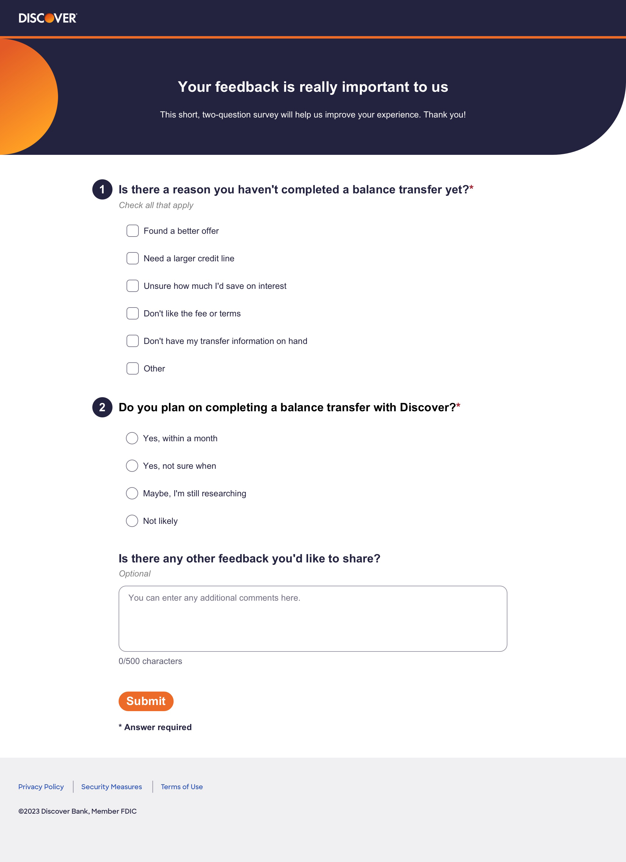
Landing page that displays when a user clicks “Take Our Survey” on the BT abandoner email (EABT).
Question 1
>>At least 1 selection is required. If no selection made and user clicks submit, display error message (see screenshot 3).
>>User may select up to all
>>When Other is selected, open text box will display (see Screenshot 2).
Question 2
>>1 selection is required. If no selection made and user clicks submit, display error message (see screenshot 3).
>>Only 1 selection can be made
Other Feedback
>>Optional (may submit without response)
>>As the user types, the counter dynamically updates to show the typed character count. If the user types 224 characters, then the counter displays “224/500 characters”. Since the field is restricted to 500 characters, at most, it displays “500/500 characters.”

Screenshot 2 – Survey Filled
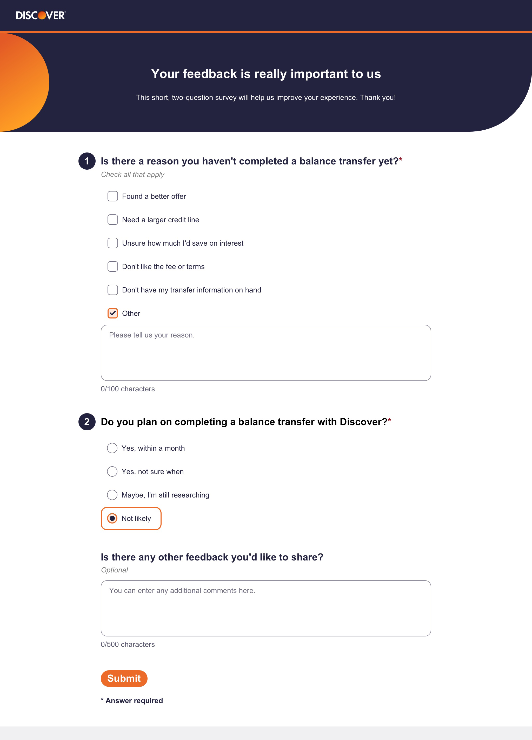
Survey filled state.
Question 1
>>In this case, the user selects “Other” and sees an additional text field display.
>>This optional field (no response needed to submit) displays when the user selects “Other” and is restricted to 100 characters.

>>As the user types, the counter dynamically updates to show the typed character count. If the user types 24 characters, then the counter displays “24/100 characters”. Since the field is restricted to 100 characters, at most, it displays “100/100 characters.”

Question 2
>>Orange box renders around selection
Button: Submit
>>If the form is submitted with invalid or no input, display error message (see screenshot 3).
>>If the form is submitted with valid input, display confirmation message (see screenshot 4).

Screenshot 3 – Error State
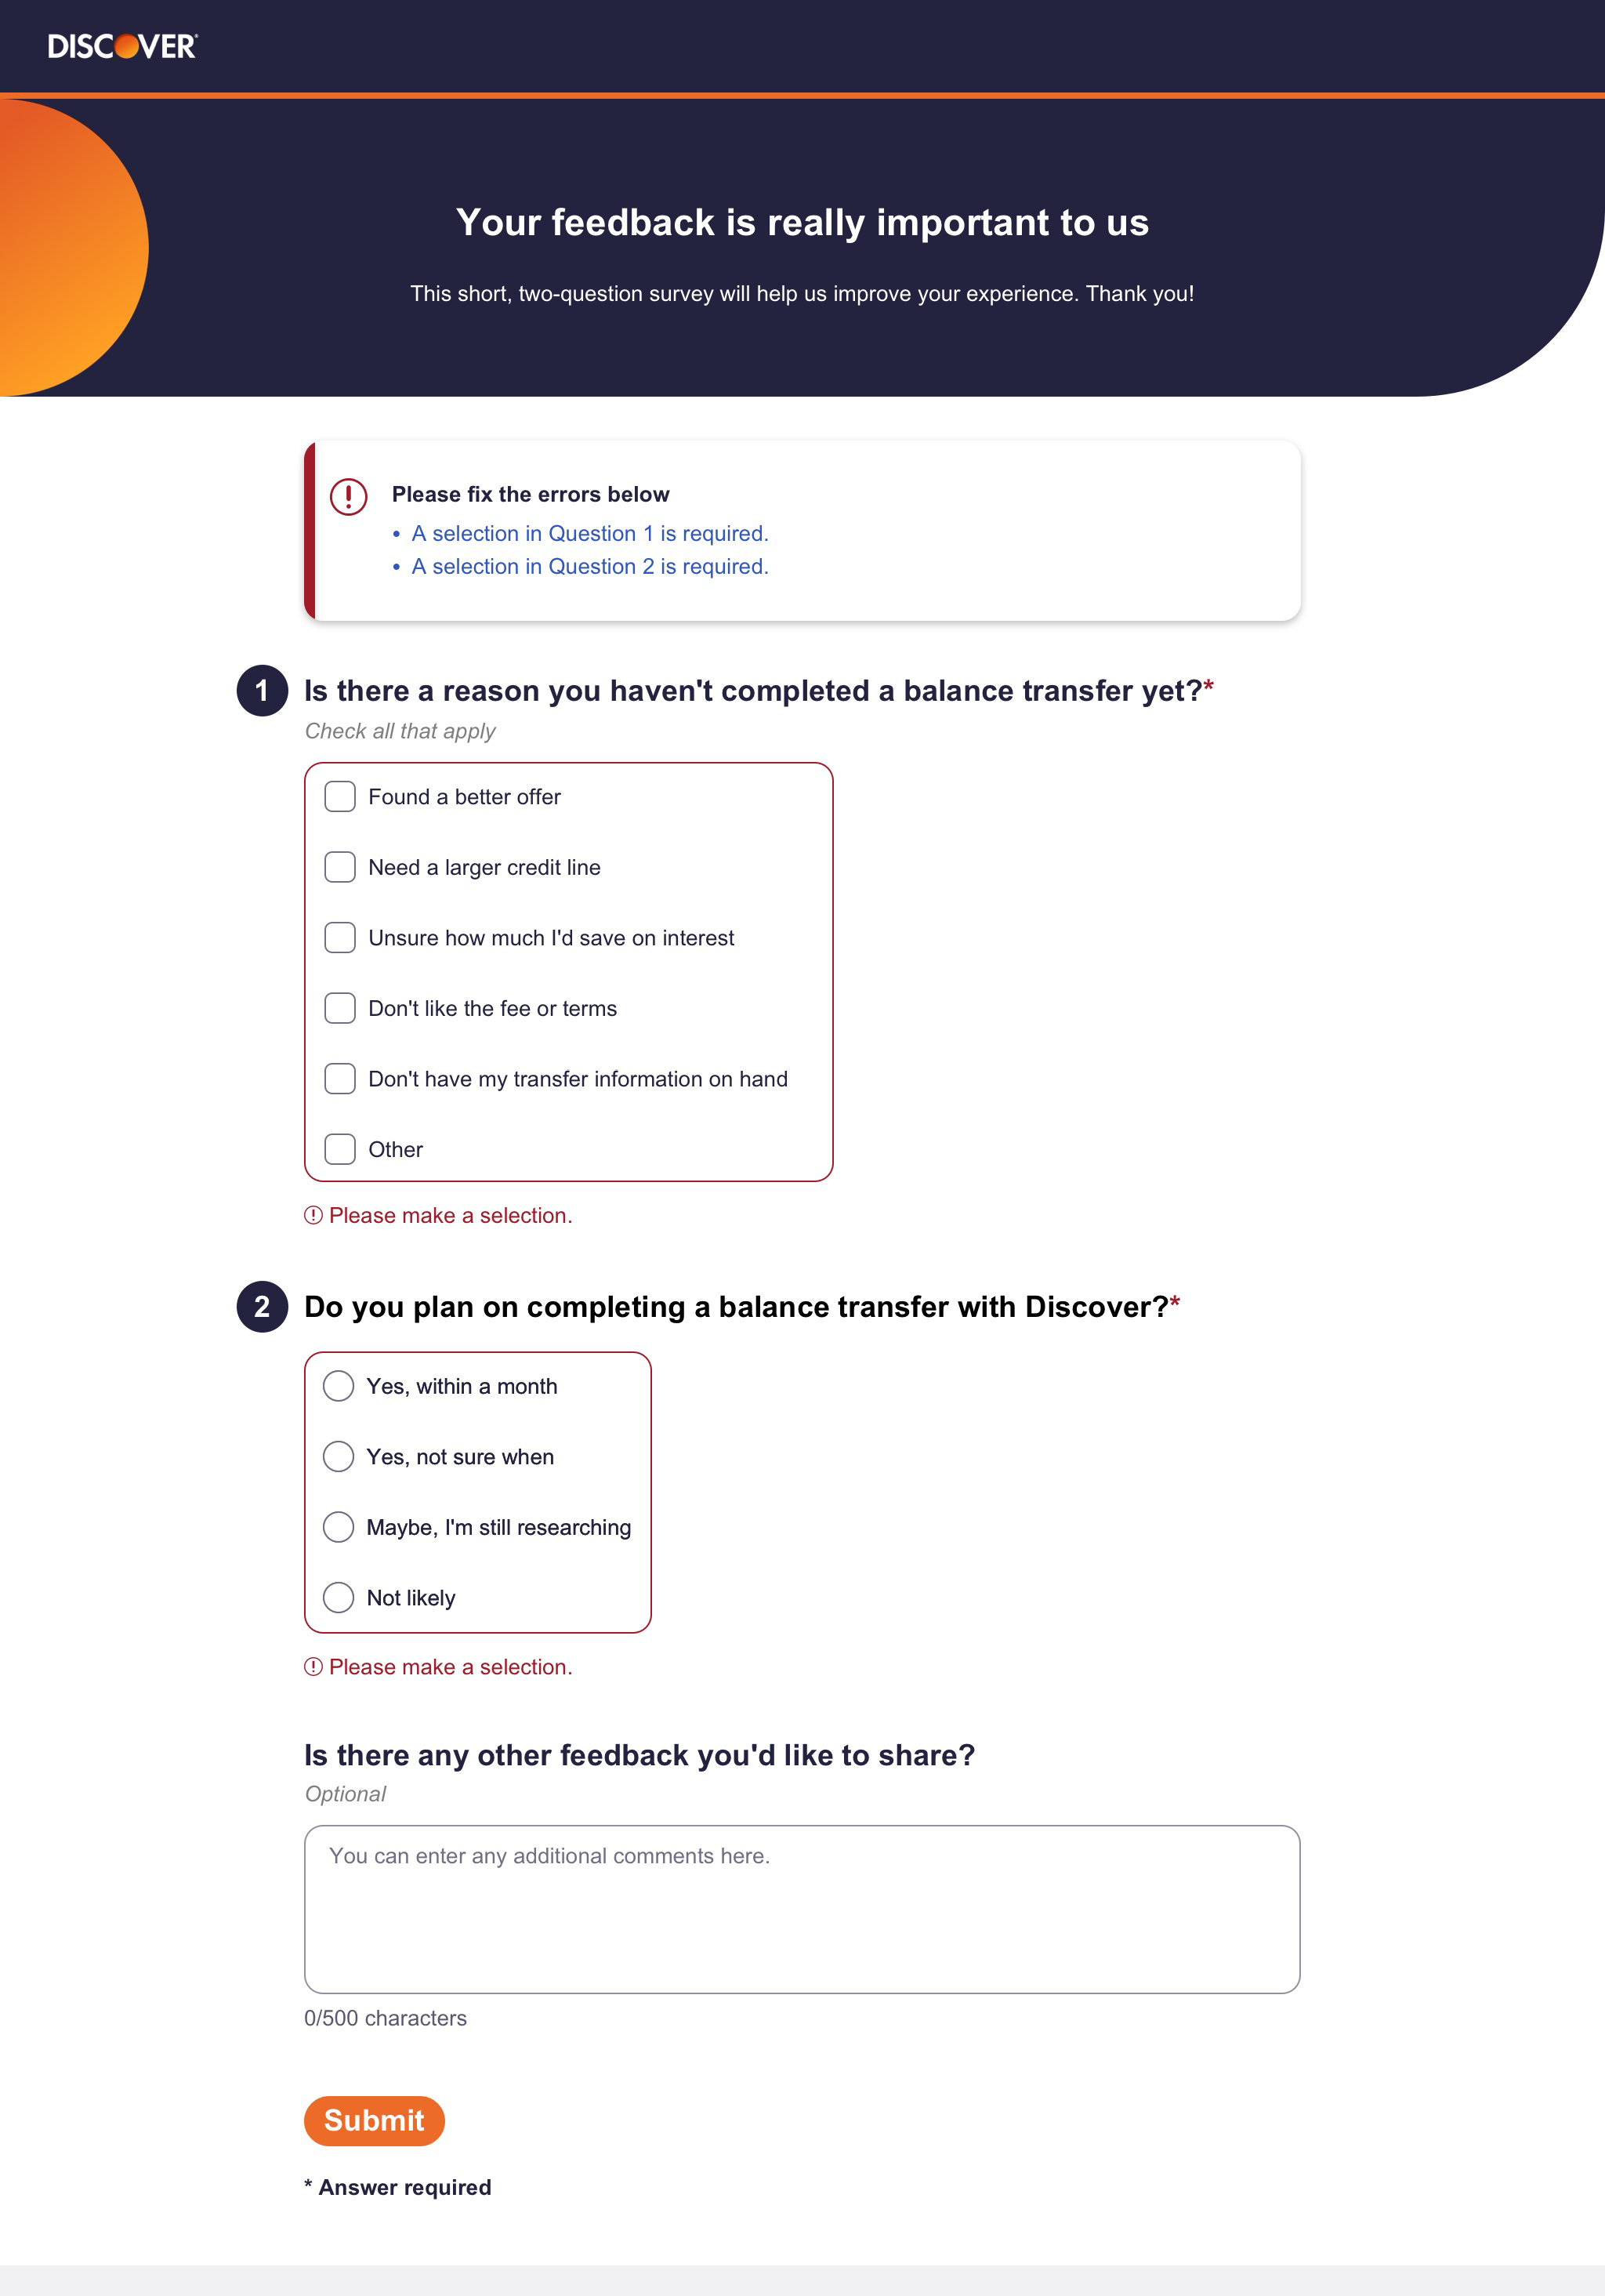
Survey error state displays after user attempts to submit survey without providing all required responses. This example is submitting a blank form.
Interaction Notes:
>>The error summary at the top only displays when there is more than one error. If there is only a single error, suppress this error summary.
>>The links in the error summary are anchor links and scroll the user’s browser position to the top of the form field with error.
>>Once a selection is made, the red outline and red error text suppress.

Screenshot 4 – Confirmation Page
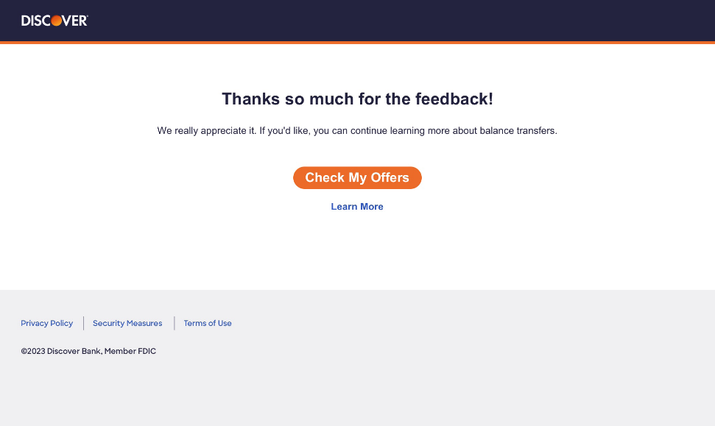

Mobile Screenshots
